Question 1: Household Water-Usage & Billing Monitor
1a) Data Types:

Write a Java program to store and display the following details of a household:

Number of family members – integer
Water consumed in litres – decimal value
House number – integer
Water usage status – character
Use appropriate Java data types for each value and display all the details.
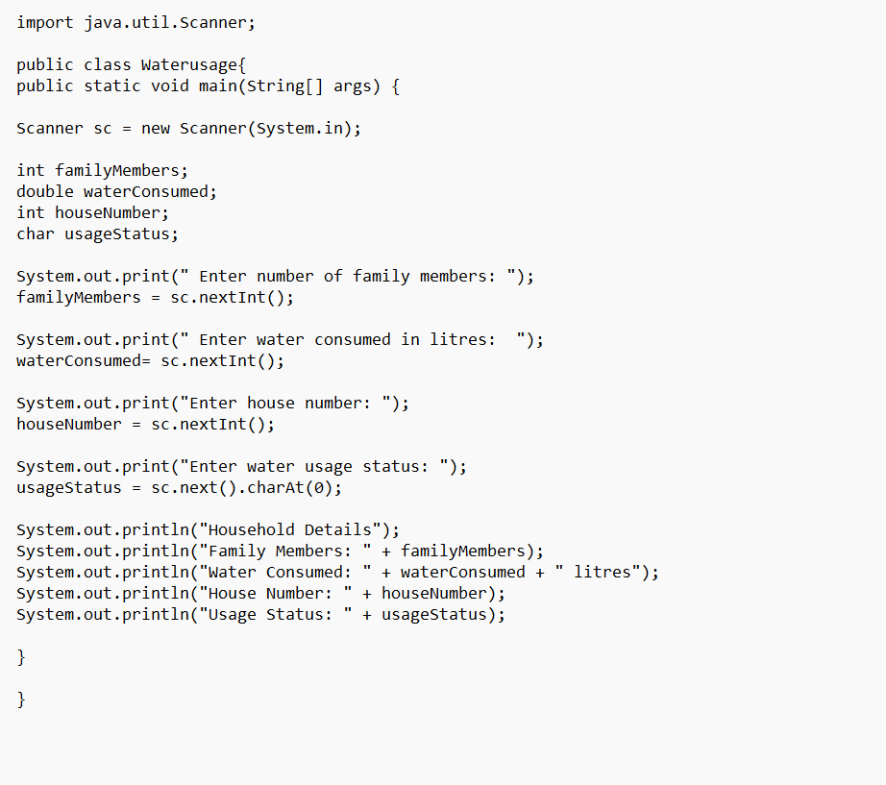
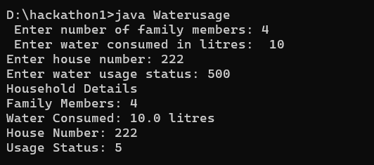

1b) If-Else Condition:

Write a Java program to calculate the water bill based on water consumption. Read the water consumption in litres.

If consumption is 500 litres or less, the bill is Rs.100.
If consumption is more than 500 litres, the bill is Rs.200.
Use an if-else statement and display the water bill.

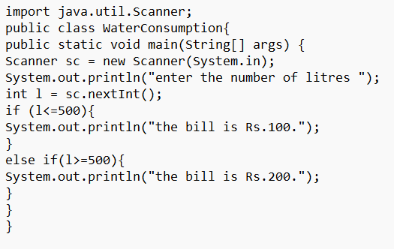
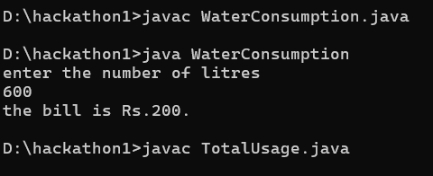

1c) Methods:

Write a Java program to calculate the total water consumption of a household using a method.

Create the following method:

calculateTotal(int morningUsage, int eveningUsage)
The method should return the total water consumption. Read the morning and evening water usage from the user, call the method, and display the total consumption.
